Subject: ICT |  | TEACHER(S) | Ms. Dipti
Week of: 9 | Grade: 11 | COORDINATOR | Mr. Rafat
Unit/Topic: |  | Content-Based Learning Outcomes  Course Objective(s): Set up Python using IDLE, VS Code, or Jupyter Notebook  Skill-Based Learning Outcomes  Course Objective(s): Write and run your first simple Python script: print “Hello World!”
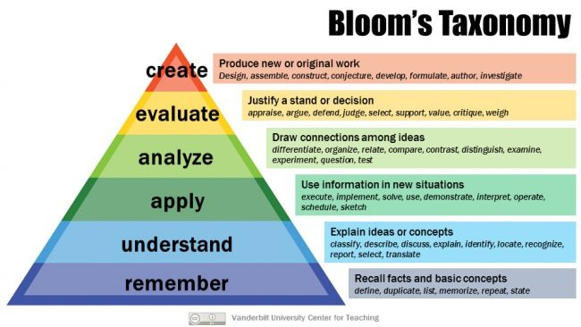
Upcoming Assessments: Ongoing Quizzes
RECOMMENDATIONS & ACCOMMODATIONS for SEN/LS STUDENTS
GA /GB | Step-by-step visual guides – include screenshots for all coding, testing and debugging steps.  Peer or teacher support – allow students to work with a buddy or receive 1:1 guidance during exercises and the quiz.

LESSON PLAN
LESSON OUTCOMES
LO1: | Set up Python using IDLE - Programiz IDE
LO2: | Write and run your first simple Python script: print “Hello World!”

Resources: | Computers with internet access and internet browser, PPT, Worksheets, Embedded Videos, Projector or whiteboard.
Warm up activity:  This should be an anticipatory activity that links to/introduces the topic. (5-10 min) | MINDS ON:
 | Description: | - Start with a recap and ask: “Where is Python used in real life? ”  - Briefly explain that Python is one of the most widely used programming languages globally.
 | UAE connection: | - Highlight the usage of python in UAE smart city projects, AI Strategies and Mobile applications.
 | Early finishers: | - Ask students to list one example of a situation in daily life where Python programming could help make things more efficient
Learning Experience(s):  What are the students doing in class? How long is the activity? What is the teacher doing? (30 – 40 min) | ACTIVITY 1: | Introduction to Python + IDE Setup (15 min)
 | Description: | Teacher introduces the concept of Python by:  - Presenting a short video clip and some simple examples  - Explains indentation and discuss with students why it is important in Python  - Briefly explains other IDE’s ((IDLE, VS Code, Jupyter) and shares a video tutorial on Programiz IDE  Students in pair open Programiz IDE on their systems and explore.  Students individually run the statements presented for learning Python.
 | Scaffolding: | - Step-by-step instructions on identifying patterns to look for indentations  - Step-by-step instructions for navigating Programiz
 | Extension: | - Ask students to explore one additional IDE feature or research a python use case in the UAE
 | ACTIVITY 2: | Writing and Running First Script (15 min)
 | Description: | Teacher presents:  - A few basic Python commands eg- print “Hello World!”  - An error in a statement  - Explain briefly keywords syntax and common errors.  Students practice coding by:  - Typing and running them in the IDE  - Identifying and fixing errors
 | Scaffolding: | - The teacher demonstrates expected output and explain common mistakes  - Circulate to support student individually
 | Extension: | Students modify the print statement to include new text
 | ACTIVITY 3: | Debugging and Commenting (15 min)
 | Description: | - The teacher explains the rules of the activity and distributes the worksheet with code snippets.  - Students work in groups to  - Fix indentation  - Add comments  - Explain their changes ( 5 mins for discussion)  - The teacher guides and clarifies common misconceptions.
 | Scaffolding: | - Remind students to use indentation correctly and how to use # for comments  - Circulate to support student individually
 | Extension: | Give students a code and ask them to write it as a clean code, by adding proper comments and indentations
CFU/Exit ticket:  How will you gauge understanding of the concepts taught? How will the students reflect on the lesson’s outcomes? (5-10 min) | EXIT TICKET:
 | Description: | Discuss the key takeaways with the students and talk about what they learnt by asking reflective questions like:  - Which Python IDE are we using,  - What is the meaning of the keyword print  Optional: Play a short Blooket quiz to review vocabulary (syntax, indentation, comments, keywords, IDE, errors).
 | Early finishers: | Write an extra print statement or a short greeting program in the IDE
 | Homework: | No homework but the students are encouraged to go over the keywords covered in the class in order to reinforce the key concepts

